**Questions:**

Do floating plant species have redundant or complimentary responses to environmental conditions?

What is the effect of temperature and nutrients on the growth rate of duckweed species

**Exeperimental Desgin:**

**Analyses:**

**Relevant Literature:**

*Duckweed growth rate:*

*Functional group / growth form complimentarity / redundancy:*

**Initial area**

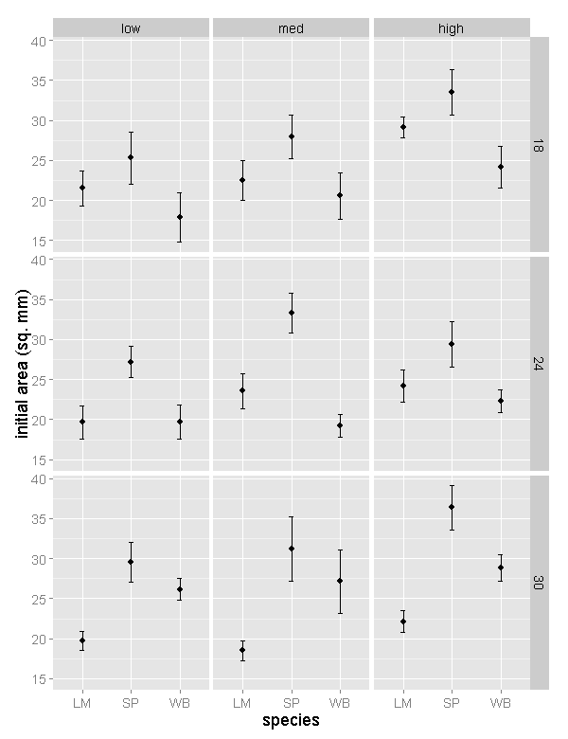

**Preliminary ANOVA suggests:**

* There is a significant difference between **species** (SP is different both LM & WB) for initial area.
* There is a significant difference between **nutrients** (high is different from low) for initial area.
* There is also a significant **interaction** between **species and temperature.**